ENTREES ARE SERVED WITH FRESH VEGETABLES & YOUR CHOICE OF WILD RICE, BAKED POTATO, MASHED POTATO OR FRENCH FRIES.
SWEET POTATO FRIES·ADD 2.00
I
I I<• ...- - I

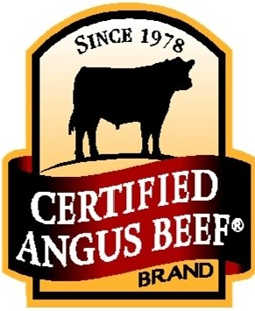V A LLEY C UT

OUR BEEF IS EXCEPTIONAL.

IT OFFERS THE INCREDIBLE FLAVOR, TENDERNESS AND JUICINESS ONLY
FOUND IN THE CERTIFIED ANGUS BEEF BRAND. INDULGE YOUR TA STE BUDS TODAY
7oz SIRLOIN STEAK
19.75

L OG G E R S C UT
10oz RIB-EYE STEAK TOPPED WITH SAUTEED MUSHROOMS 26.00

FAVORITE STEAK TOPPINGS
SAUTEED MUSHROOMS & ONIONS 2.95
NEPTUNE (SEA FOOD IN C REAM SAUC E) 4.95
FA NTA IL SHRIMP (4) 6.25
SKILLET SIDE ORDERS
Garlic Sauteed Mushrooms 4.95
Sauteed Tiger Prawns 6.25

COCON UT ·CU RRY RICE BOWL
MIXED V EGETABLE S SERVED IN A CREAM Y COCONUT CURR Y SAUCE . S ERV ED OV ER W ILD RICE AND W ITH GAR LIC TOA ST Y OUR CHOICE O F CHICKEN OR JUMB O SHRIMP
18.50

HUCKLEBERRY CHICKEN SALMON LOIN

GRILLED TENDER CHICKEN BREAST.
TOPPED WITH HUCKLEBERRY SAUCE & MELTED MOZZARELLA CHEESE. 17.00
GR ILLED IN LEMON HERB BUTTER
-OR - POACHED WITH LEMON & DILL. 17.50

HUNTER SCHNITZEL
SWISS CHICKEN DINNER TENDER BREADED PORK LOIN TOPPED WITH

GRILLED TENDER CHICKEN BREAST TOPPED WITH FRESH SLICED TOMATO, SWISS & PAR MESAN CHEESES. 17.00
A RED WINE GRAVY W ITH DICED TOMATO, ONION, GREEN PEPPER, MUSH ROOMS & BACON BITS . 18 .75

MUSHROOM SCHNITZEL GRILLED CHICKEN BREAST DINNER TE NDER BR EADED PORK LOIN TOPP ED WITH

GR ILLED TENDER CHICKEN BREAST. 14 .50
A RED WINE GRAVY & MUSHROOMS . 17.75

SALISBURY STEAK NEPTUNE SCHNITZEL

OUR HAND-MADE JUICY SEASONED BEEF PATTY TOPPED WITH SAUTEED ONIONS & GRAVY . 15 .00
TENDER BREADED PORK LOIN TOPPED WITH A CREAMY SEAFOOD SAUCE. 19.75

BABY BEEF LIVER & ONION

TE NDER LIVER TOPP ED WIT H SAUTEED O NIONS, GRAVY
2 PCE. 15 .75
1PCE. 13 .00

